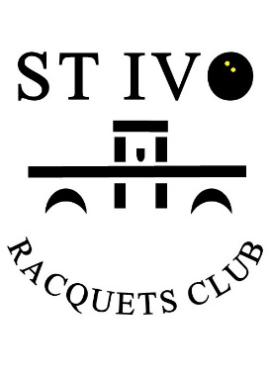
St Ivo Racquets Club
One Leisure Outdoor Centre
California Road
St. Ives
PE27 6SJ www.stivo-squash.co.uk
GRADED SQUASH OPEN
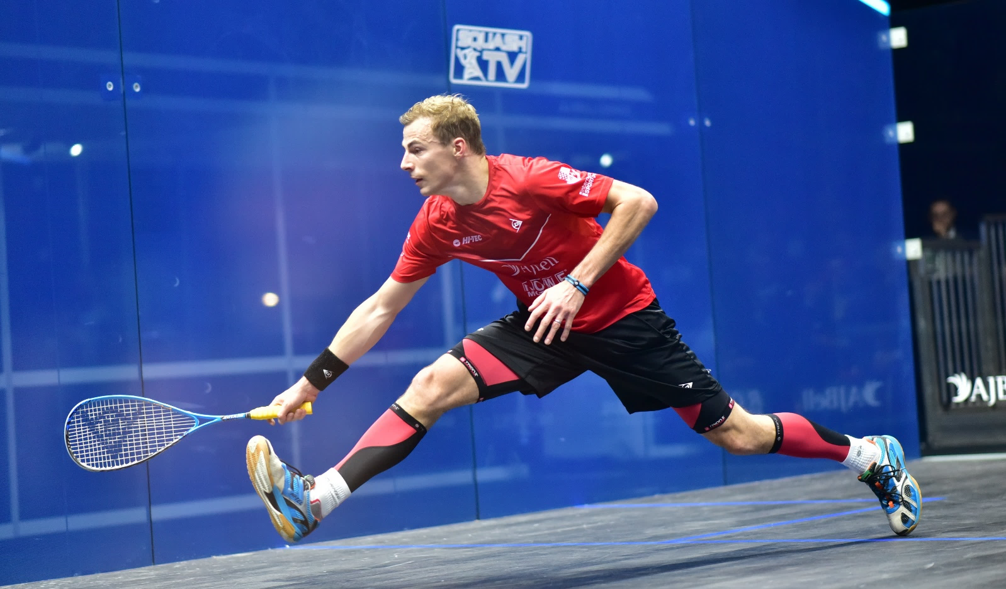
SUNDAY 12TH MAY 2019

A GRADE – CAMBS MIXED TEAM PLAYERS
B GRADE – MIXED CLUB/SOCIAL PLAYERS
WOMEN’S OPEN
We are opening up our club championships to all players in the area to join us in supporting our cause to keep our squash courts from closure.
£5 entry fee – min 2 matches guaranteed.
To enter please text or email John Dewis on 07855447402 or johnnydewis39@gmail.com with your name, tel no, email address and preferred grade, A, B or Women’s.
Closing date for entries is 4th May 2019.
Please help us keep the great sport of squash in the town. Sign the petition at www.huntingdonshire.gov.uk

